OOP WEEK ASSIGNMENT NO 1 EXERCISES

Exercise-01

5 Objects with Attributes and Methods

no | Favourite Object | Relevant Attributes (What it has) | Behaviours (What it can do)
1 | Sports Car | brand, model, color, topSpeed, fuelLevel | startEngine(), accelerate(), brake(), drift(), turboMode()
2 | Smart Water Bottle | brand, capacity, waterLevel, temperature, color | fillWater(), drinkWater(), remindToDrink(), displayWaterLevel(), cleanBottle()
3 | Smart Backpack | brand, color, weight, batteryLevel, GPS | openBag(), lockBag(), chargePhone(), trackLocation(), storeItems()
4 | Coffee Machine | brand, waterLevel, coffeeBeans, temperature, powerStatus | makeCoffee(), heatWater(), brewCoffee(), cleanMachine(), turnOff()
5 | Smartphone | brand, model, batteryLevel, storage, camera | makeCall(), sendMessage(), takePhoto(), browseInternet(), charge()

Exercise-02

Stack and Heap Diagram For Objects

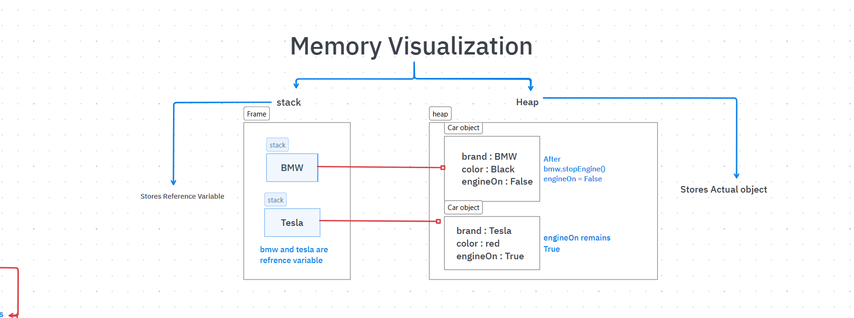

Exercise-03
Java Varargs

Objective
The purpose of this exercise is to improve the calculator by allowing it to add any number of values using Java Varargs.

Code
public double add(double... numbers) {
double total = 0;

for (double number : numbers) {
total += number;
}

return total;
}

Key Points
- double... numbers is called Varargs.
- It allows the method to accept any number of values.
- The numbers parameter behaves like an array.
- A for-each loop is used to calculate the total.
- The method returns the sum of all the given numbers.

Conclusion
This approach makes the calculator more flexible and efficient. Instead of creating different methods for different numbers of inputs, a single method can handle all cases, making the code shorter, cleaner, and easier to maintain.

